**Abstract:**

This essay focuses on terms like momentum, Newton’s Third Law of Motion, Thrust, Nuclear Propulsion and Rocket equation while answering the question: Is it possible to reach the orbit with a single stage to orbit rocket? Or do we need two or three stages?

In this research we will be looking at the rockets e.g., Falcon 9, which is the most efficient rocket until now, and uses two stages, we will be taking some data from the falcon 9 rocket and then try to manipulate some data through theory by two ways. First: By changing the design of the rocket and then introducing some new ways of manipulating the modern designs. Second: By changing the fuel which we now use (e.g., Liquid Oxygen and rocket grade Kerosene RP-2) to nuclear fuel or using the ion thrusters.

**Research Question:**

***Is it possible to reach the orbit with a single stage? Or do we need two or three stages?***

**Introduction and Background Information:**

When speaking about single-stage-to-rocket, it seems very easy to think of a rocket with a single stage reaching the orbit. But when we dive deep into the major concepts of the rockets and rocket equation we realize the draw-backs for a single stage rocket and why we need multi-staged rockets.

Also when we think about the single stage to orbit rockets we can thus reduce the computer complications required in staging and hence reduce the cost of the rocket. There were no steps taken earlier in the development of these rockets, but after looking at the efficiency and the low cost some aerospace engineers are trying the possible ways of implementing this imagination into practice. There were several approaches made for building a single-stage-to-orbit rocket. But the most concerned problem for a single staged rocket to reach the orbit is achieving high enough mass-ratio to carry sufficient propellant to reach the orbit, including payload’s weight.

Types of Fuels and their Pros and cons

When speaking about a rocket, fuel is the most important element of consideration. So, when choosing the fuel, we need to very particular about the limited options present. We will take the most efficient and the most common fuel used today, in reusable rockets (the most advanced form of rockets). The fuel they use is liquid hydrogen(LH2) along with oxidizer liquid Oxygen(LOX).

*Advantages of using Liquid Hydrogen* (LH2):

1. “Liquid hydrogen is light and extremely powerful rocket propellant,
2. It has the lowest molecular weight of any known substance and burns with extreme intensity,
3. In combination with liquid oxygen, it yields the highest specific impulse,
4. It has the highest efficiency in relation to the amount of propellant consumed, of any known rocket propellant.”

As both, the oxidizer (LOX) and the fuel (LH2) both of them being cryogenic, i.e., gases that can be liquefied only at extremely low temperatures, they have few disadvantages,

*Disadvantages of using liquid hydrogen*(LH2):

1. “Liquid hydrogen must be stored at minus 423oF and handled with extreme care,
2. Rockets fueled with liquid hydrogen must be carefully insulated from all sources of heat, to prevent it from exploding.
3. Liquid hydrogen can leak through minute pores in welded seams.”

The fuel and oxidizer discussed above could be work, but none of the tests have worked so far, for single-stage-to-orbit rockets. So, we also need to look at some fuels other than the ones used previously, two of the most discussed fuels among aerospace engineers are, Nuclear fuel (fission) or Ion thruster.

*Advantages of using Nuclear Fuel*:

1. They generate considerably more energy than chemical reactions on a per molecule basis,
2. They have a higher specific impulse, which is essentially a measure of the efficiency of rocket engine,
3. Less amount of Nuclear fuel is needed as compared to the fuels used today.

*Disadvantages of using Nuclear Fuel*:

There aren’t many disadvantages of using nuclear fuel, but the main thing to worry while using this fuel is the thrust produced by the fuel, as it produces way less thrust than any other fuel. Therefore, we need to develop some new way of engineering the engines, which will be covered in the next section.

Types of Engines with designs

For this essay we will using the data used by falcon rocket and then try out some possibilities with the rocket engine which has the maximum thrust and which is still in progress, the Raptor Engine, often, referred to as the king of engines.

Let’s start with the Engines used for Falcon Rocket:

*Merlin Engine:* This family of engines is formed by SpaceX company for their Falcon series of rockets. Merlin Engine uses the **gas-generator**(GG) cycle of Engines. In Gas Generator cycle pressurized oxidizer and fuel of a small fraction are diverted to a Gas Generator, which leads to the production of a fuel rich gas to drive the turbines. The exhaust produced from the design of these engines is either dumped overboard, or injected in the nozzle to produce extra thrust. We could obtain any desired pressure level although the ***Isp*** loss increase with pressure and we could also use the any of the available fuels.

Alongside with these advantage of getting extra pressure the Merlin engine also has some drawbacks and the drawback of most concern is its efficiency, which might somewhat affect our single staged rockets. Due to the facility of getting the desired pressure we thereby reduce the **specific impulse (*Isp*)** and hence lead to loss in the efficiency. In classical mechanics **specific impulse** is the change of momentum of a body over a time interval, which is equal to the force applied times the length of the time interval over which it is applied.

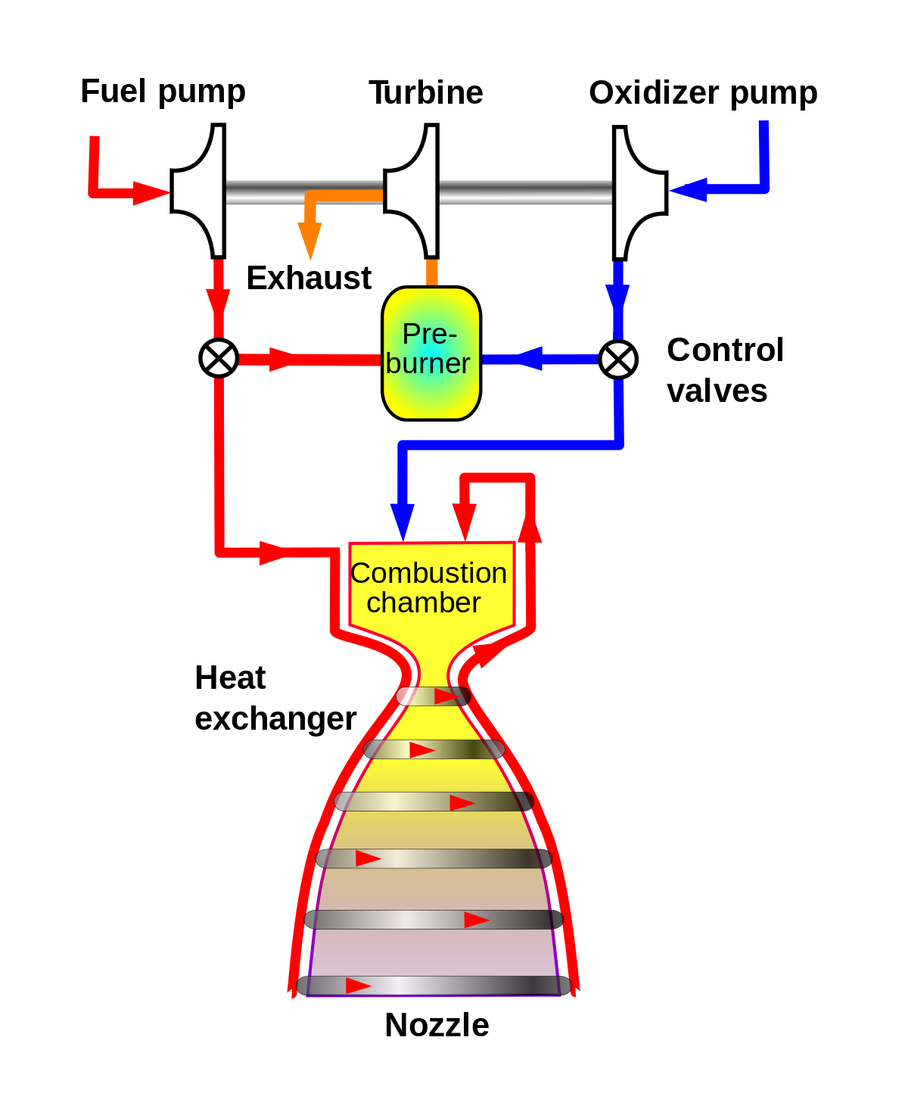

**Given above is the simplified diagram/structure of a Gas Generator Cycle Engine which is used by the Merlin Family of engines.**

After seeing this major drawback in one of the best engines till date, we need to look at Engine which is considered to have the maximum thrust once the development is done.

*Raptor Engine:* This Engine is also being developed by the SpaceX company which also developed the Merlin Engines. The factor which makes Raptor Engine different from the Merlin is, it uses the **staged combustion** cycle of engines. Using this cycle makes the Engine much complicated than the GG cycle but it also increases thrust. This Engine is being designed to use Liquid Methane as the fuel and Liquid Oxygen as the oxidizer. In staged combustion cycle we can achieve both high chamber pressure as well as high efficiency. In this cycle the entire fuel and oxidizer is used in the combustion chamber itself. Although this engine comes with greater complexity, but it provides the best performance, because it has many ducts and valves involved and also it has high pump exit pressures.

As this engine is going to use Methane as the fuel, which might be the reason for the specific impulse which we got, but if we change the fuel to liquid hydrogen we have the chance of increasing the efficiency by 30-40%, as seen in advantages of using LH2.

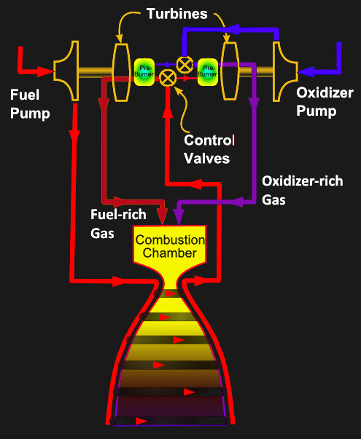

**Given above is the diagram explaining briefly about the SpaceX’s Raptor Engine and thereby giving a brief knowledge about the staged combustion cycle.**

The Two Engines discussed above are quite possible to make, and also give some of the expected results. But apart from these two engines we will also have to think of some new design to back these engines and the most likely answer to that is using the Nuclear Thermal Engine.

*Nuclear Thermal Engine:* This is a completely theoretical concept, but if put in practice, it has high chances of working and give the expected results, but also it will have few drawbacks which we will discuss further. As the name suggests this engine uses Nuclear reactor instead of Liquid oxygen, it also used liquid hydrogen. Oxidizer is not used in this process because we are using reactor to produce the hot stuff required for producing thrust.

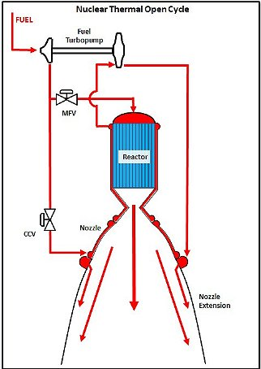

**Given above is the diagram of the nuclear engine which uses open expander cycle of engines, the red part in the picture is the Liquid Hydrogen.**

The hot generated is also used for producing thrust. Main reason for using hydrogen as fuel is, firstly is light and due to its lightness when it is heated it gets energetic and hence starts moving fast. So, looking at the rocket equation we know that fast moving exhaust means high performance. As these engines are twice more efficient than the engines mentioned above.

There are two main drawbacks for using this engine is:

1. Nuclear fusion leads to a massive explosion,
2. The radiation produced due to the burning of nuclear fuel, it may cause serious health issues for the people nearby.

Now we will be looking at efficiencies of the respective engines, probably the first two and then also look at some calculations required for the SSTO’s to reach the orbit. Thrust produced by:

1. Merlin 1d Engine is 3050*103 N, and,
2. Raptor Engine is 654333 N.

Now we will find efficiencies of the two engines by calculating specific impulse (**Isp**), we use the term specific impulse because the higher the specific impulse the higher the efficiency.

What is specific impulse (**Isp**)?

As we know that the specific impulse is measured is seconds but we will see how it is related to efficiency, suppose the engine has a specific impulse of ‘x’ seconds, a unit mass m, of propellant can generate enough thrust to support its weight.

Formula: Isp =

Calculating the efficiencies of the two given engines, take g = 9.81 constant:

1. Merlin 1d engine:

Thrust (T): 654,333 Newton,

Mass flow rate ($\dot{m}$): 236.6 Kg/sec,



 *s*

This is a quite good specific impulse, if we look at the engines present today, this is the most efficient engine created so far,

1. Raptor engine:

Thrust (T):  Newton,

Mass flow rate ($\dot{m}$): 931.2 Kg/sec,



 *s*

If we compare the two engines, then for Raptor we get more thrust for a longer period of time thus making it most efficient engine.

Calculations for reaching the orbit

So far we have the efficiencies of the rocket engines which are undoubtedly the best engine present till date. But now we also need to find certain values for the rocket to reach the orbit. First let us find out the velocity required for the rocket to reach the orbit. For finding this we will be using Kepler’s formula for the speed required to reach the orbit.



V = Velocity required to reach the orbit,

R = Mean Earth Radius (6371 km),

g = Gravitational constant at sea-level (9.81 m/sec),

h = Height of the orbit.

We are going to find the calculations required for the rocket to reach the low earth orbit, i.e., anywhere from 160 km to 1000 km, distance, so we will keep the height of the to 200 km.

* 
* m/sec,

So, for a rocket to reach the low-earth orbit at an altitude of 200 km the velocity of the rocket flying should be minimum 7784.42 m/sec. Now, we will be discussing about the velocities which can be achieved by the two engines.

For calculating the velocity which each engine can reach, we need to use the specific impulses calculated for the respective engines.



VR = Velocity of the rocket engine,

g = Gravitational constant at sea-level (9.81 m/sec),

Isp = Calculated specific impulse

1. Merlin 1d engine:



1. Raptor engine:



The velocities produced by the respective engines is comparatively low compared to the required velocity to reach the altitude of 200 meter. But, it is not as easy as it looks, we also have to take in consideration the change in velocity as the mass decreases constantly as the fuel get ejected.

So, the initial momentum of the system is

.

The exhaust velocity of gases is .

So, as a result of the ejection of gases the velocity of the rocket increases by , and the mass decreases by . Therefore, including the change of the rocket and the change for the exhaust, the final momentum of the system is:



Since all vectors are in X-direction, we drop the vector notation. Applying the conservation of momentum, we obtain,



Now, integrating from the initial mass *mi* to the final mass m of the rocket gives us the result we are after:



And thus our final result is,



Here, *u* = VR (VR is calculated for the respective engines)

The result achieved is called **rocket equation**. It gives us the change of velocity that rocket obtains from burning a mass of fuel that decreases the total rocket mass from *m*0 down to m.

So, let us find the velocity change for the rocket using Merlin 1d engine, which is probably falcon 9. So the total initial mass (mi) of the falcon 9 rocket is 549,054 kg, and the mass of payload to the low-earth orbit is 22,800 kg. Thus the mass of the rocket is too high, we therefore need the sufficient thrust, so that we could lift such a heavy mass, therefore spaceX uses 9 Merlin Engines thereby creating a thrust of 7607 kN, i.e., around 1.7 million pounds.

Now, finding the change of velocity the rocket obtains from burning a mass of fuel is:



km/sec,

These were the results obtained if we use Merlin engines, and it states that if the entire fuel is burned the change of velocity will be around 8.5 km/sec. Now, let us have a look at the same falcon 9 but by using Raptor Engine, it is not quite practical to compare Raptor engine for a falcon 9 rocket, because using these engines will lead to increase in the mass, due to complexity in the engine.

For Raptor:



km/sec,

We see that the velocity obtained for falcon 9 is quite high if we use Raptor engine, but we should consider mass of falcon 9, which was taken similar to falcon 9 using merlin engines. But this scenario with Raptor engine is not quite possible as the weight will increase if we install these engines.

There is another property which is of great concern for the rockets and that property is nothing but mass, as we saw in the above Raptor engine scenario that lowering the mass increases the chances for SSTO to be possible, but we will be seeing **Mass** in more detail.

The mass of a rocket can make the difference between a successful flight and an unsuccessful flight. As a basic principle of physics, we should know that for a rocket to fly engine must produce thrust more than the mass of the rocket. It is obvious that the rocket with unessential mass will not be as efficient as one that is trimmed to just the bare essentials.

The rockets which we have seen till know we know that the mass distribution of rocket is: 90% is the propellant mass, 6% is the mass of structure and 4% is the payload mass.

To determine the effectiveness of the rocket design, we need a term called Mass-fraction.